VPC TASK – 01

1)Create VPC with 2 private and 2 public subnets.

* Open VPC Console → Subnets → Create Subnet
* Select the VPC ID: my-vpc-01
* Enter a Subnet Name: Public-subnet-01
* Choose Availability Zone no preference
* Enter IPv4 CIDR Block: 172.168.0.0/26
* Total 64 Ips

2)Enable DNS Hostname in VPC.

* Open AWS Management Console
* In the top search bar, type **VPC**.
* Click on **VPC** service.
* My-VPC-01
* A panel opens at the bottom.
* Click the **Details** tab.
* On the right side, click **Edit VPC settings**.
* Turn ON both checkboxes:
* **DNS resolution**
* **DNS hostnames**
* Click **Save changes**

3)Enable Auto Assign Public IP in 2 public subnets

* Go to **AWS Console**
* Open **VPC** service
* **Select Public-subnet-01**
* From the subnet list, click **Public-subnet-01**
* Click **Subnet actions** dropdown
* Select **Edit subnet settings**
* Enable auto-assign public IPv4 address
* Click **Save**
* **Select Public-subnet-02**
* Click on **Public-subnet-02**
* Click **Subnet actions**
* Choose **Edit subnet settings**
* Enable auto-assign public IPv4 address
* Click **Save**

4) Add 2 private subnets in private route table

* **Open Route Tables**
* Go to **AWS Console**
* Open **VPC** service
* click **Route Tables**
* Open Subnet Associations
* Click the **Subnet associations** tab
* Then click **Edit subnet associations**
* Select Both Private Subnets
* **Private-subnet-01**
* **Private-subnet-02**
* Click **Save associations**

5) Add 2 public subnets in public route table.

* **Open Route Tables**
* Go to **AWS Console**
* Open **VPC** service
* **Open Subnet Associations**
* In the bottom details panel:
* Click **Subnet associations** tab
* Then click **Edit subnet associations**
* Select Both Public Subnets 1 and 2
* **Public-subnet-01**
* **Public-subnet-02**
* Click **Save associations**

6) Public route table will have the routes to internet and local.

* **Open Internet Gateways**
* Go to **AWS Console**
* Open **VPC** service
* Click **Create internet gateway**
* Name it: **MyIGW**
* After creating → Select it
* Click **Actions → Attach to VPC**
* Choose your VPC (**my-vpc-01)**
* VPC → Route Tables → public-rt → Routes → Edit routes

| * **Destination** | * **Target** |
| --- | --- |
| * **0.0.0.0/0** | * Internet Gateway (**MyIGW**) |

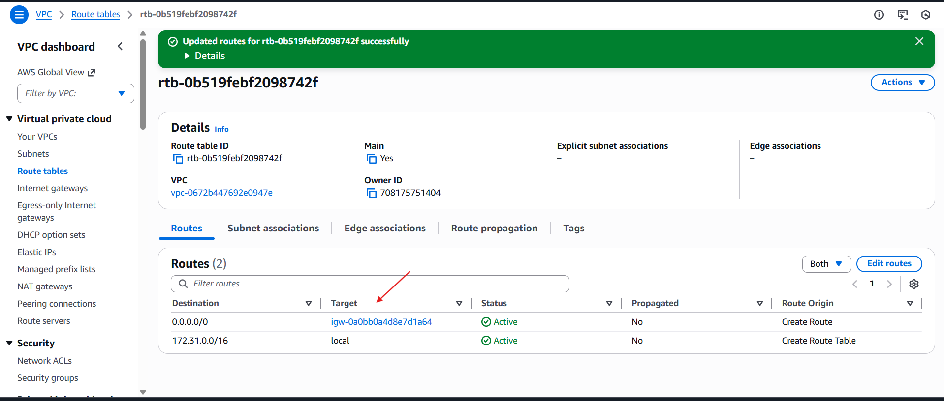

7) Create EC2 in public subnet with t2.micro and install PHP

* Search for **EC2**
* Launch EC2 Instance
* Select the Amazon Linux AMI
* Under Network Settings, choose your VPC and select the public subnet.
* • In the Security Group, add the following inbound rules:
* • SSH (port 22) • HTTP (port 80)
* ssh -i your-key.pem ec2-user@<Public-IP>
* sudo yum update -y
* sudo yum install httpd -y
* systemctl status httpd
* sudo systemctl start httpd
* sudo yum install -y php php-cli php-mysqlnd

